# **Biological trade-offs underlie coral reef ecosystem functioning: figures**

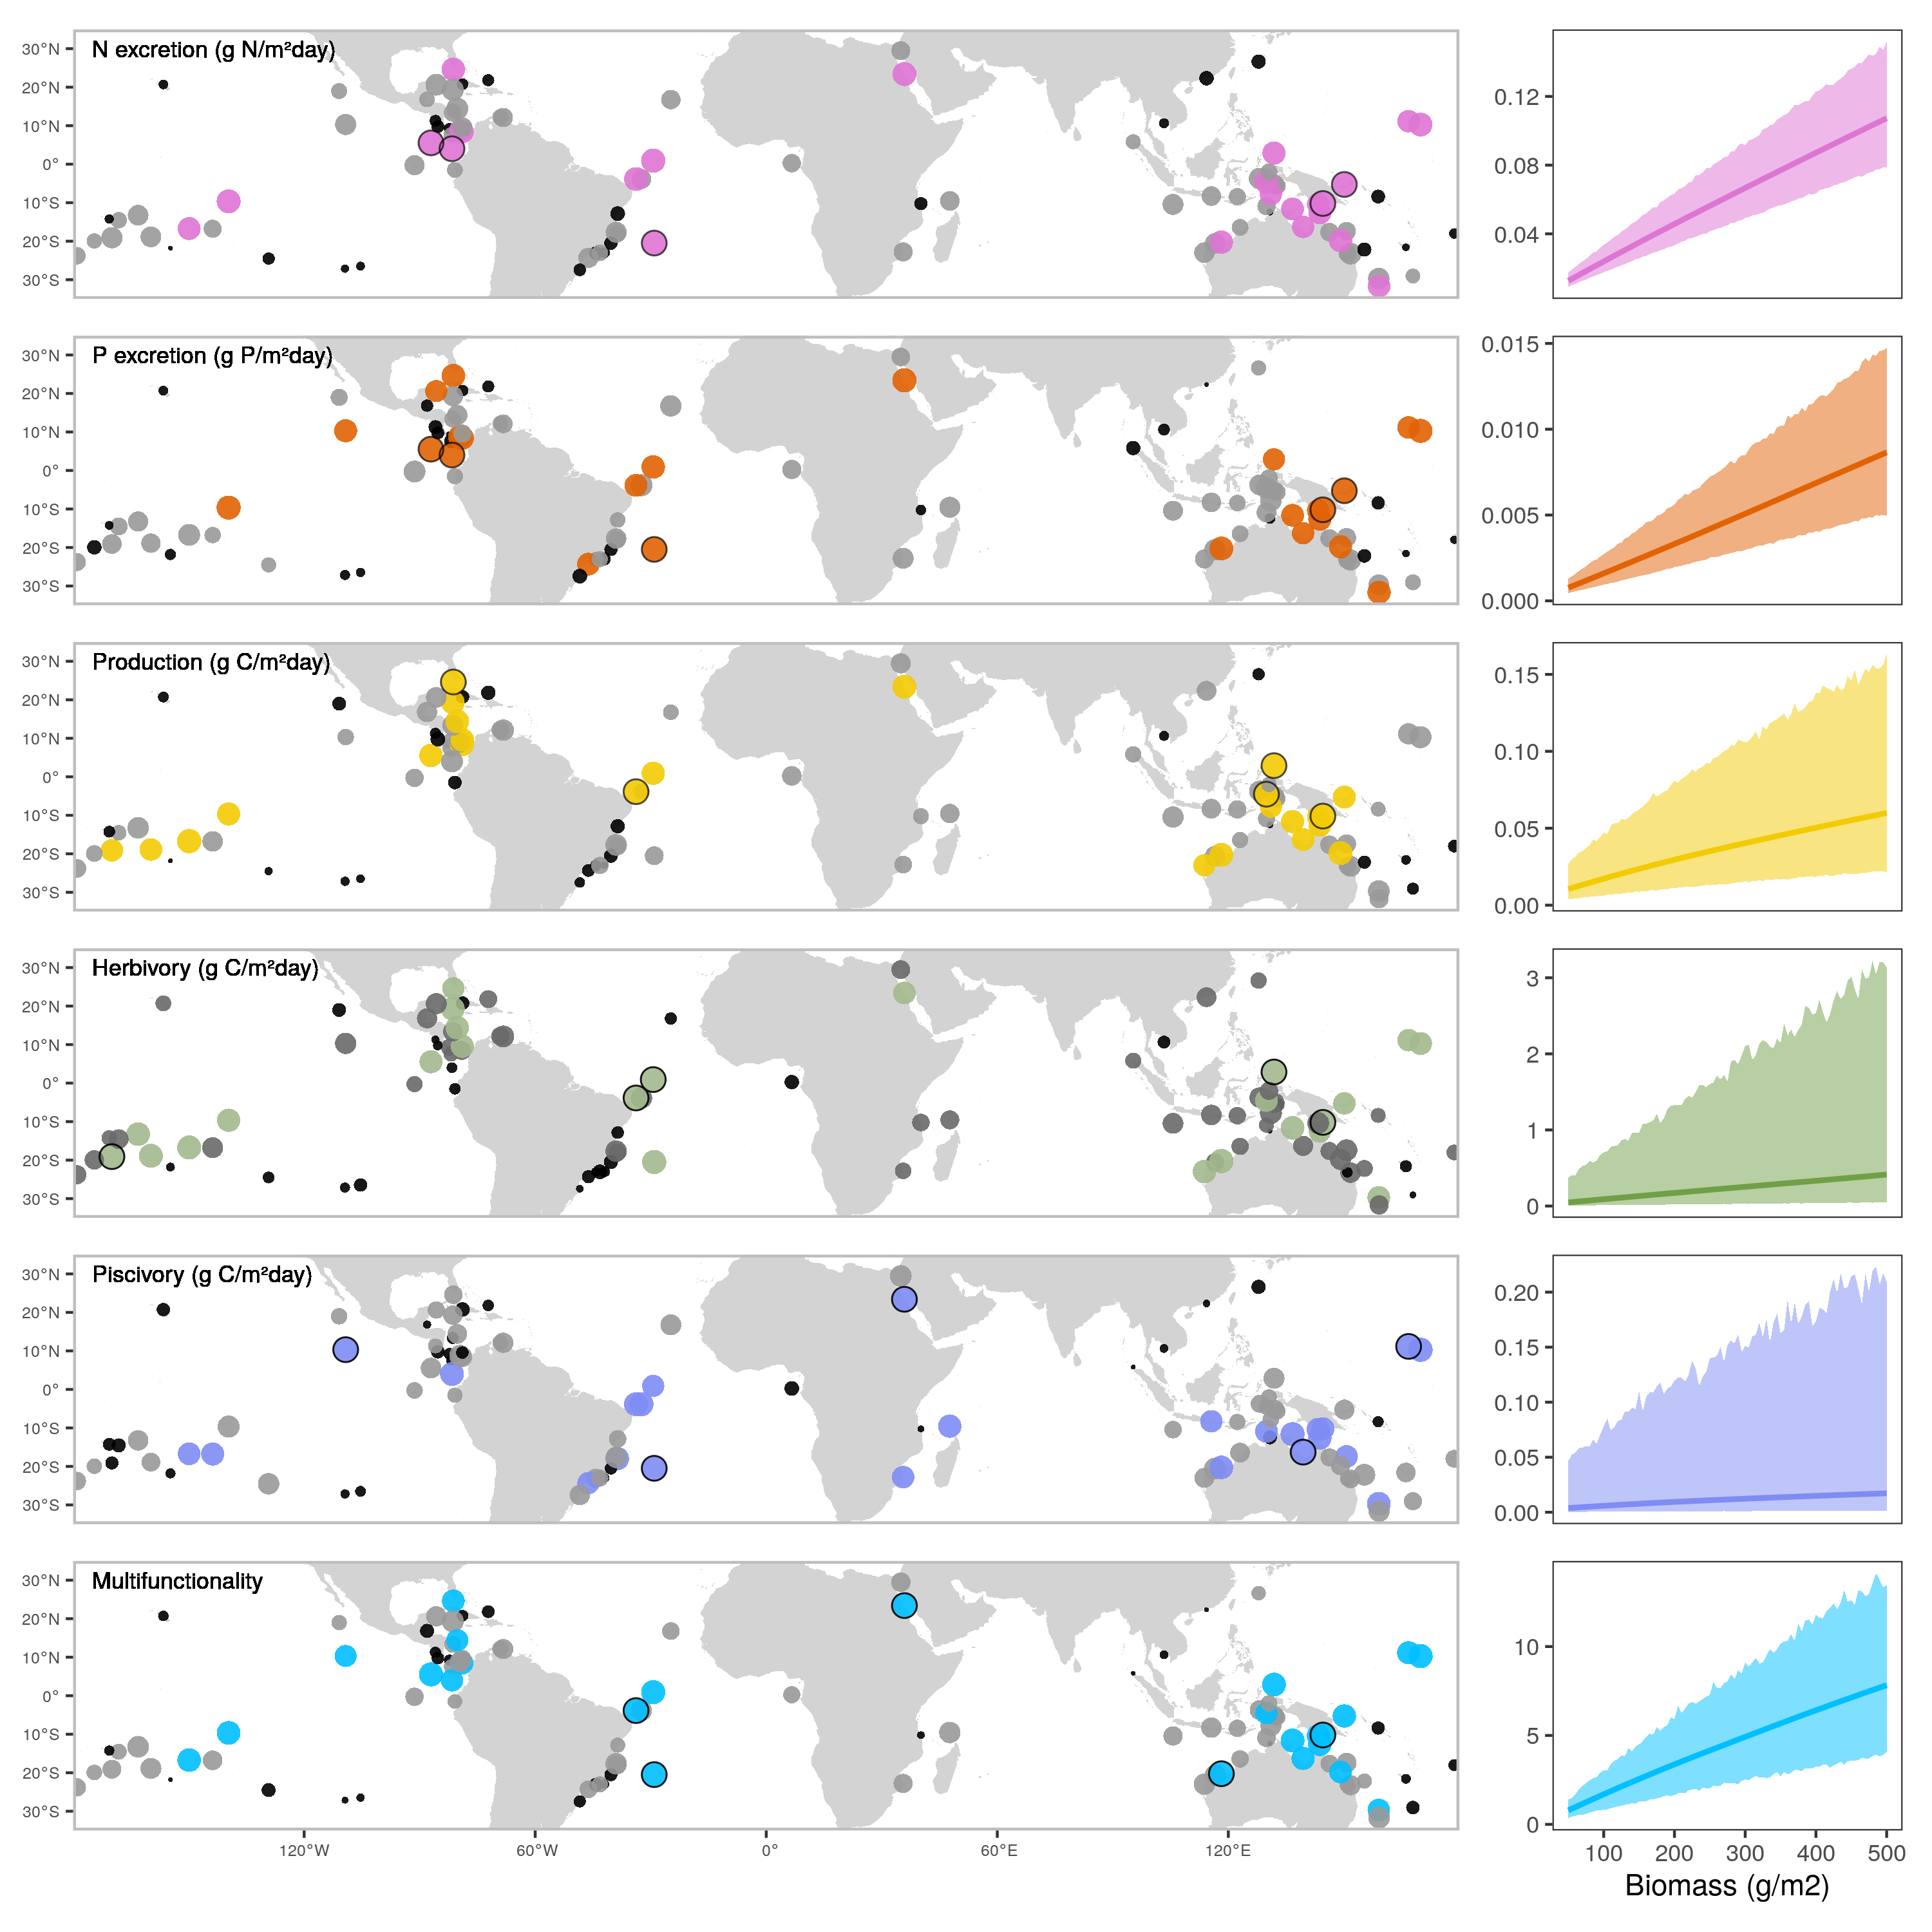**Fig. 1: Maps of five key ecosystem functions and multifunction, and their relationships with biomass.** Left: Dots indicate localities of field surveys, with dot sizes representing the ranked values of the locality-level predictions of functions, and color scales showing categorical assignments (black = lower 25%, grey = 25-75%, color = >75%). Black circular outlines highlight the five localities with the highest values of each function. Multifunction represents the weighted average of the five standardized functions. Right: The predicted values for functions and multifunction with increasing biomass. The lines represent the average predicted value and the shaded areas show the 95% credible interval of he predictions.

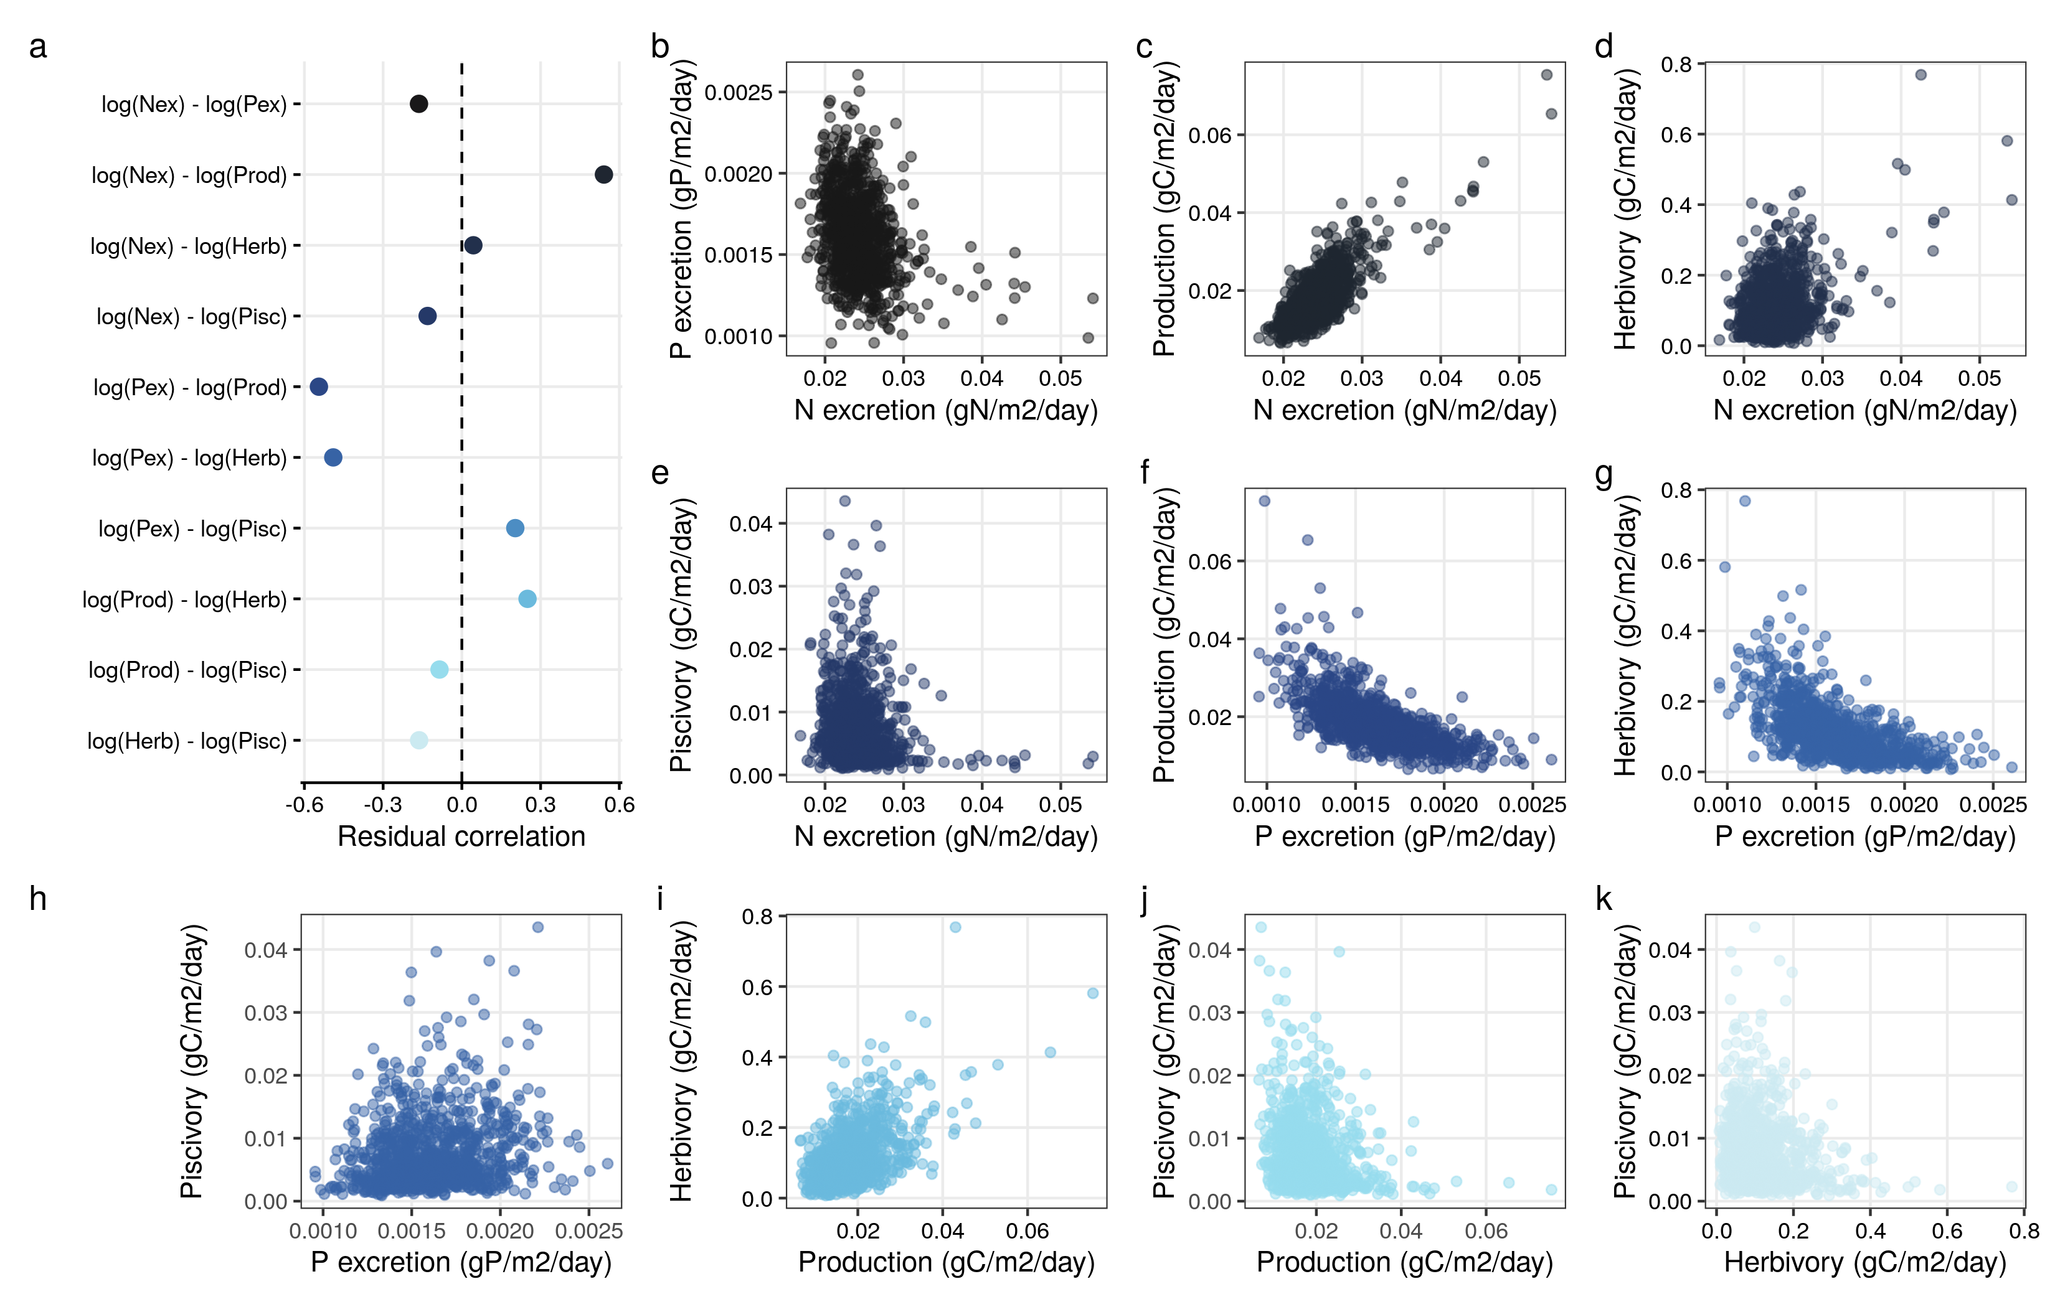**Fig. 2: Correlations among five functions while accounting for biomass and sea surface temperature.** a: Modeled correlation coefficients of residual errors. Dots represent the average and lines represent the 95%CI. b-k: Scatter plots of the mean residual error of the functions to demonstrate the correlations.

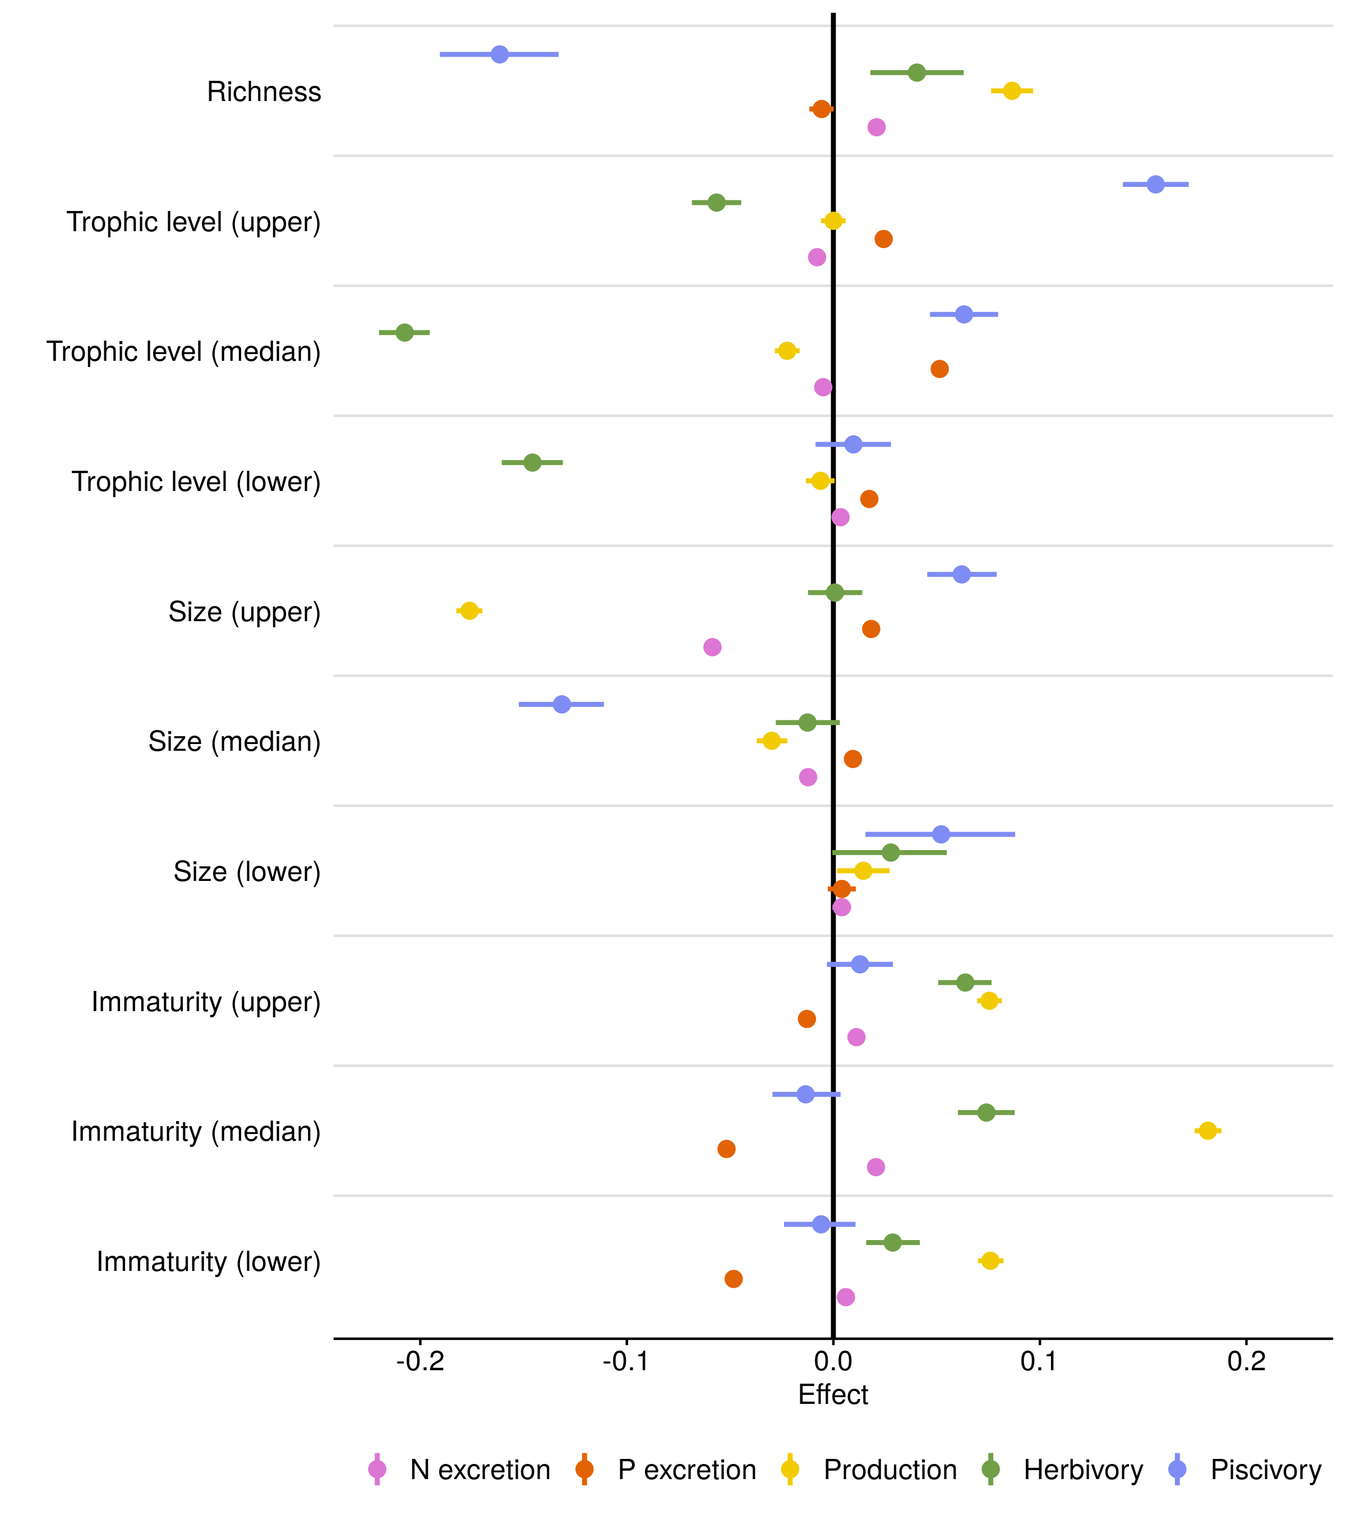**Fig. 3: Effects of ecological community variables on five functions.** Fixed effect values from Bayesian linear regressions that examine effects of species richness, trophic level, size, and immaturity of fishes. To represent both the median and the spread of trophic level, size, and immaturity across individuals inside a community, we included lower and upper 95% quantile values of these three traits as community variables (indicated with ‘lower’ and ‘upper’). All functions were log-transformed and standardized and all variables were standardized to compare parameter values across functions and variables (see Table S2 for parameter values on non-standardized data). Dots represent the average effect size estimate, and horizontal lines indicate the 95% credible interval.

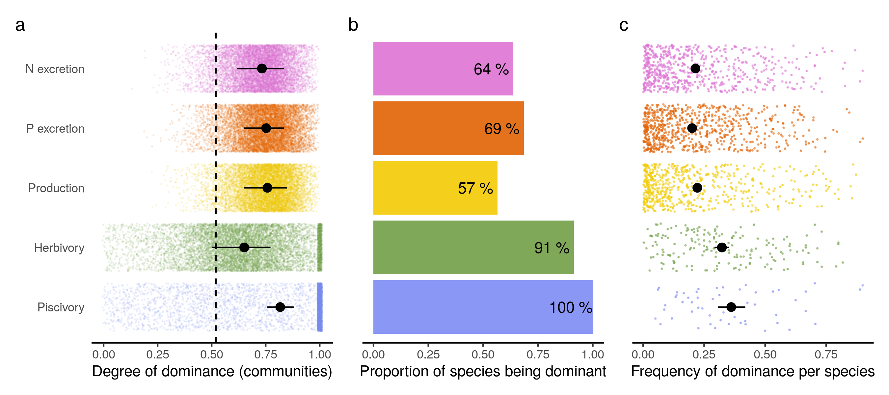**Fig. 4: Dominance in species contributions for five ecosystem functions on coral reefs.** a: The degree of dominance of communities for each function. Colored dots represent the raw values and the black dots and lines display the mean and 95% credible intervals of the average degree of dominance, respectively. Degrees of dominance range between zero (all species contribute equally) and one (a single species is the sole contributor to a given function). The vertical dashed line shows the average of the degree of dominance of 1,000 randomly simulated communities. b: Bar plot showing the proportion of species that are dominant in at least one transect relative to the total number of species. In the case of herbivory and piscivory, the total number of herbivores and piscivores, respectively, is used. c: Species-specific frequencies of dominance in each function across all communities, ranging from zero (species are never dominant) to one (dominant wherever present). A species is categorized as dominant in a community if its contribution to a function is higher than a scenario in which all species are equal (i.e. one divided by the number of species that contribute to the function).

Site level???

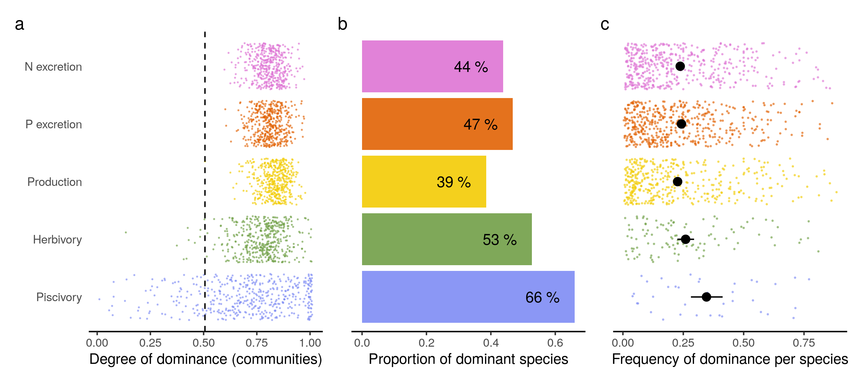

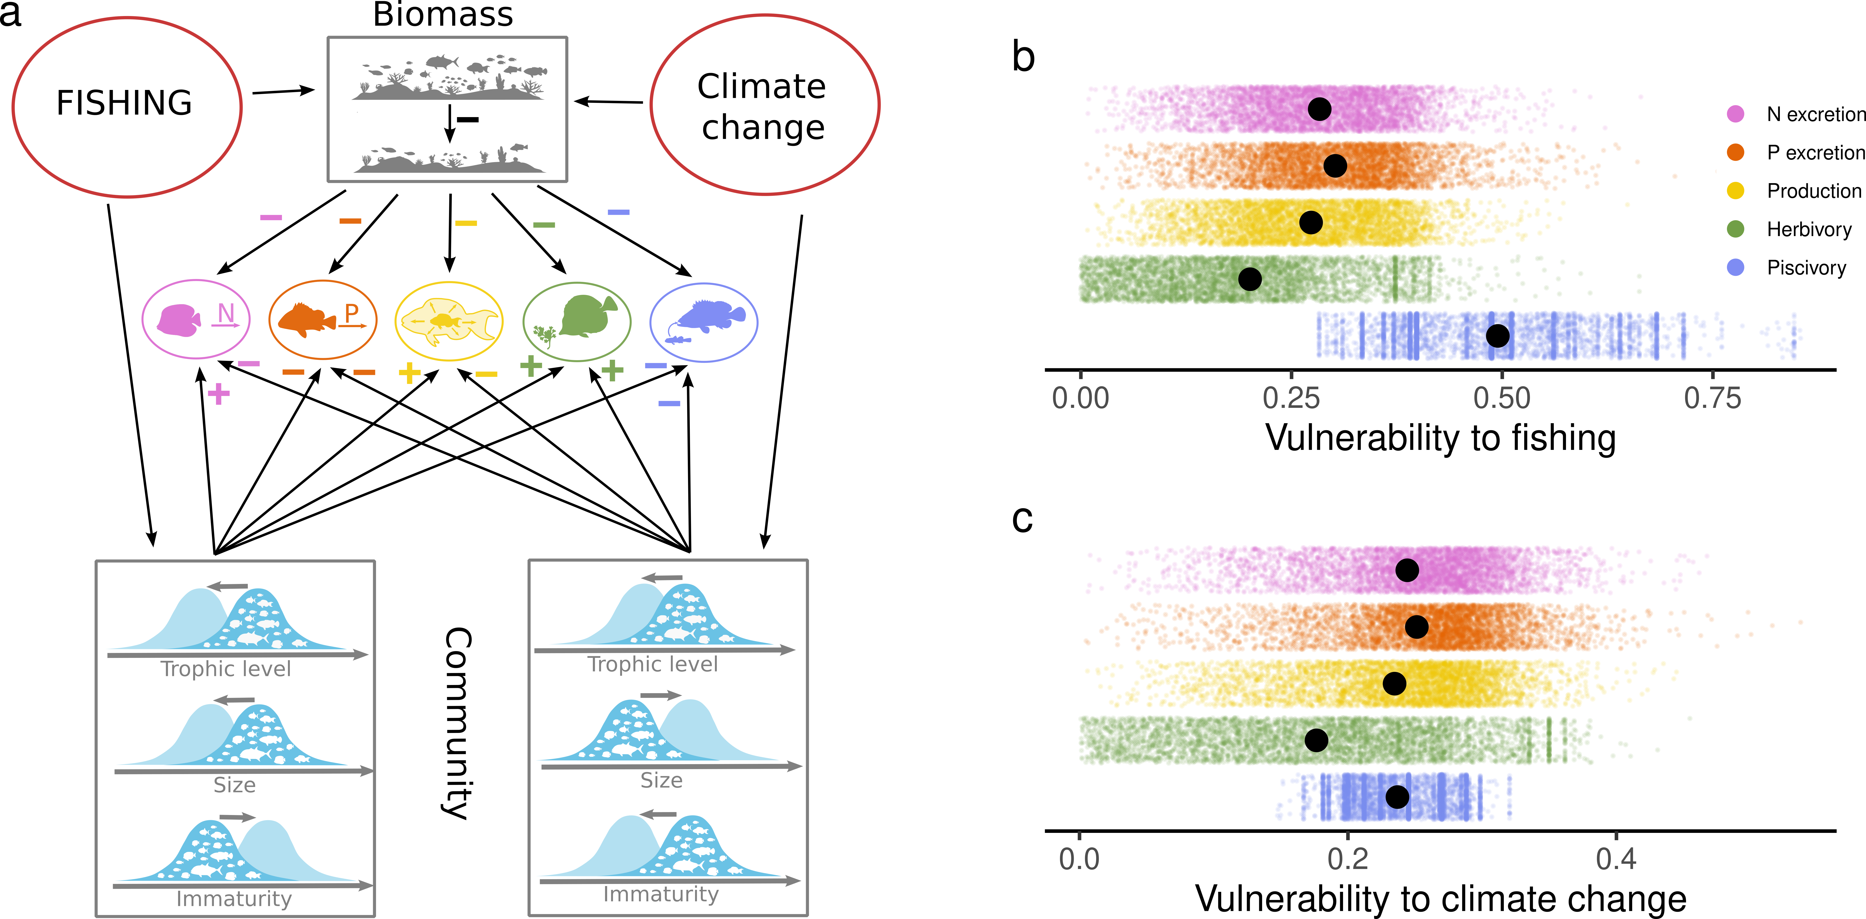

**Fig. 5: Vulnerability to fishing and climate change for five key fish-mediated functions on coral reefs.** a: Conceptual diagram displaying the ways in which fishing and climate change can affect functions. b: Vulnerability to fishing of fish communities for each function based on a contribution-weighted average of species-level vulnerabilities to fishing. c: Vulnerability to climate change of fish communities for each function based on a contribution-weighted average of species-level vulnerabilities to coral loss. Colored dots show transect-level vulnerability estimates and black dots show the average fitted value for each function. The credible intervals of the fitted values were too small for display but are reported in supplementary table xx.